**University of Barishal (BU)**



**Assignment On**

**Comprehensive Project using and office Application**

**COURSE TITLE : Computer Fundamental and office application**

**Submitted To:**

Dr. Md Manjur Ahmed

Associate Professor

Department Of Computer Science and Engineering

University Of Barishal

**Submitted By:**

MD.Showrab hosen saikot

Roll: 01-039-07

Department of Finance & Banking

University Of Barishal

Date of Submission: 04-12-2024

**Contents**

1 Executive Summary: 1

2 Products and Services: 1

2.1 Products: 1

2.1.1 Laptops: 1

2.1.2 Desktops: 1

2.1.3 Tablets: 2

2.1.4 Smartphones: 2

2.2 Services: 2

3 Business Plan: 3

4 Sales and Cost Statistics: 4

# Executive Summary:

XYZ Company is a leading provider of innovative electronic smart devices. Committed to delivering cutting-edge technology, the company aims to enhance connectivity, productivity, and lifestyle experiences for its global customer base.

# Products and Services:

## Products:

### Laptops:

High-performance [laptops](https://www.nytimes.com/wirecutter/reviews/best-laptops/) designed for productivity, gaming, and entertainment, featuring the latest processors and sleek designs.

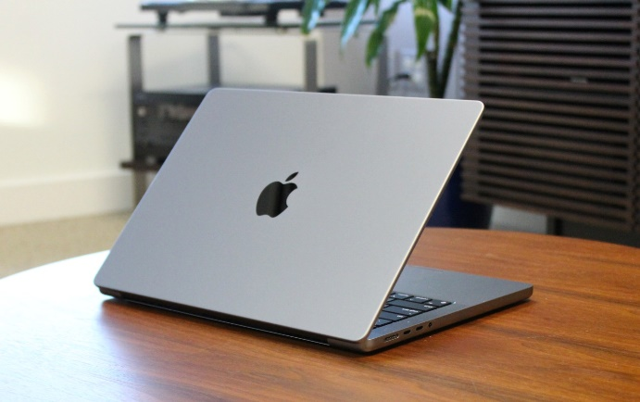

### Desktops:

Versatile [desktops](https://www.nytimes.com/wirecutter/reviews/cheap-desktop-pcs/) tailored for professional and personal use, offering powerful configurations and customizable options.

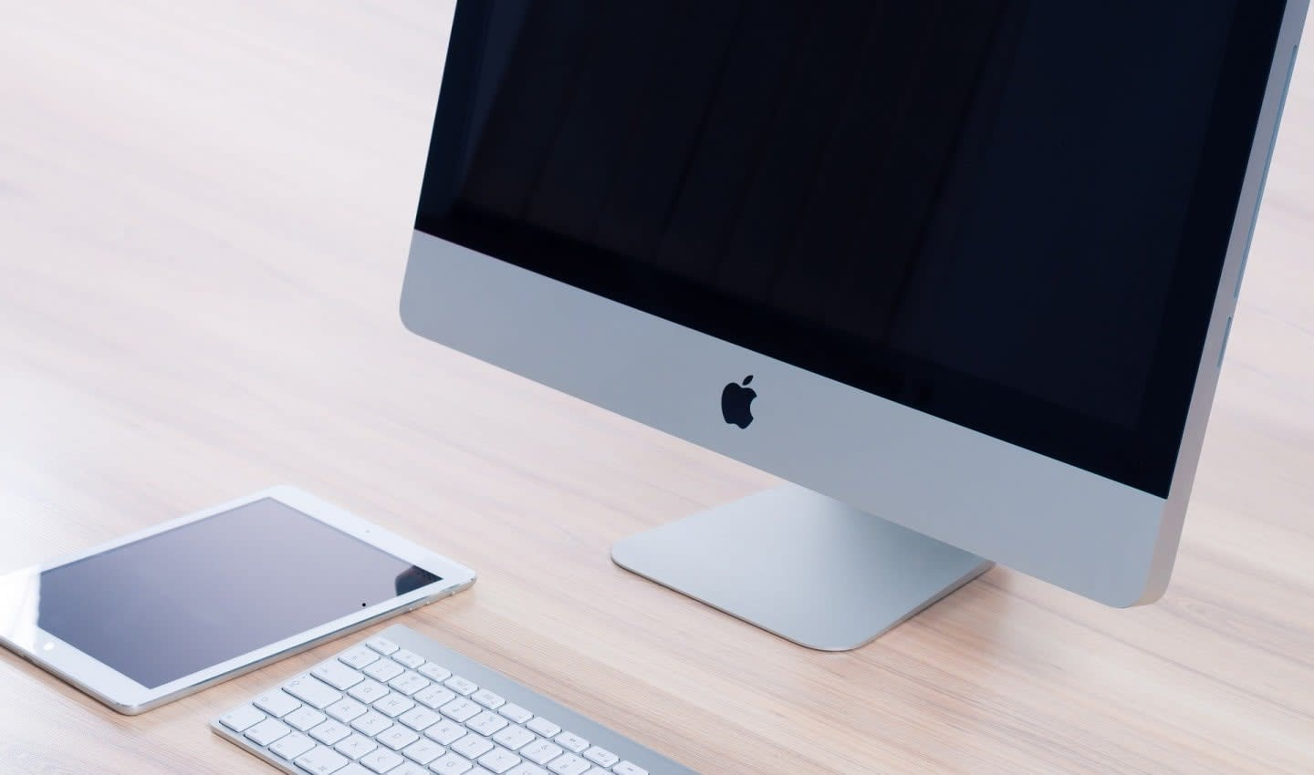

### Tablets:

Lightweight and portable [tablets](https://www.nytimes.com/wirecutter/reviews/best-tablets/) with vibrant displays and multitasking capabilities, ideal for work, learning, and entertainment.

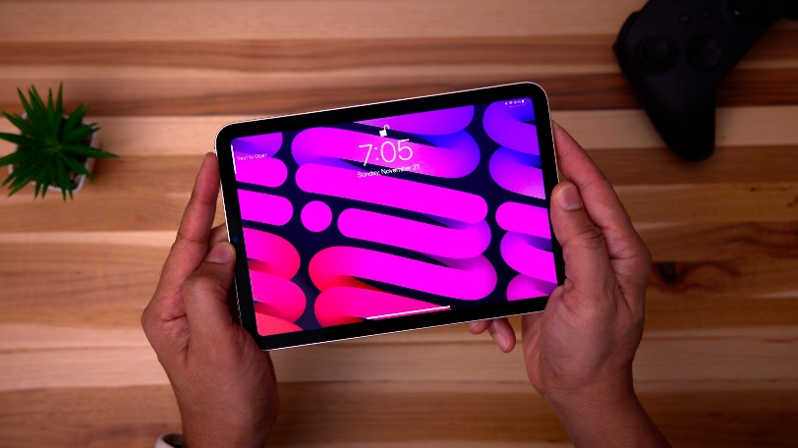

### Smartphones:

Feature-rich [smartphones](https://www.nytimes.com/wirecutter/reviews/best-smartphones/) with advanced cameras, long-lasting batteries, and seamless connectivity for everyday needs.

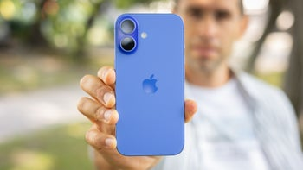

## Services:

* **Warranty and Support:**

Comprehensive product warranties and 24/7 customer support for troubleshooting and repairs.

* **Customization:** Personalized device configurations to suit individual and business needs.
* **Software Updates:** Regular updates to enhance performance, security, and device features.
* **Recycling Program:** Environmentally friendly recycling services for old or unused devices.

# Business Plan:

**No**

**Customer from US**

**Process new customer record**

**Submit to controller for approval**

**No**

**Yes**

**Process order**

**Input Order**

**Input Order Info System**

**Purchase order received**

**Current Customer**

**Yes**

# Sales and Cost Statistics:

|  |  |  |  |
| --- | --- | --- | --- |
| Product | Quantity | Cost | Sales |
| Laptop | 5 | 70,000 | 350,000 |
| Desktop | 3 | 50,000 | 150,000 |
| Tablet | 5 | 20,000 | 100,000 |
| Smart Phone | 10 | 80,000 | 800,000 |